WALKTHROUGH HA-FORENSICS

* *Today we are going to crack this vulnerable machine called HA: Forensics. This is a Capture the Flag type of challenge. It contains FOUR flags that are accessible as the solving of the lab progresses based on hints. It is a Forensics focused machine. Here’s is the machine link:*

*https://vulnhub.com/entry/ha-forensics,570/*

FLAG 1

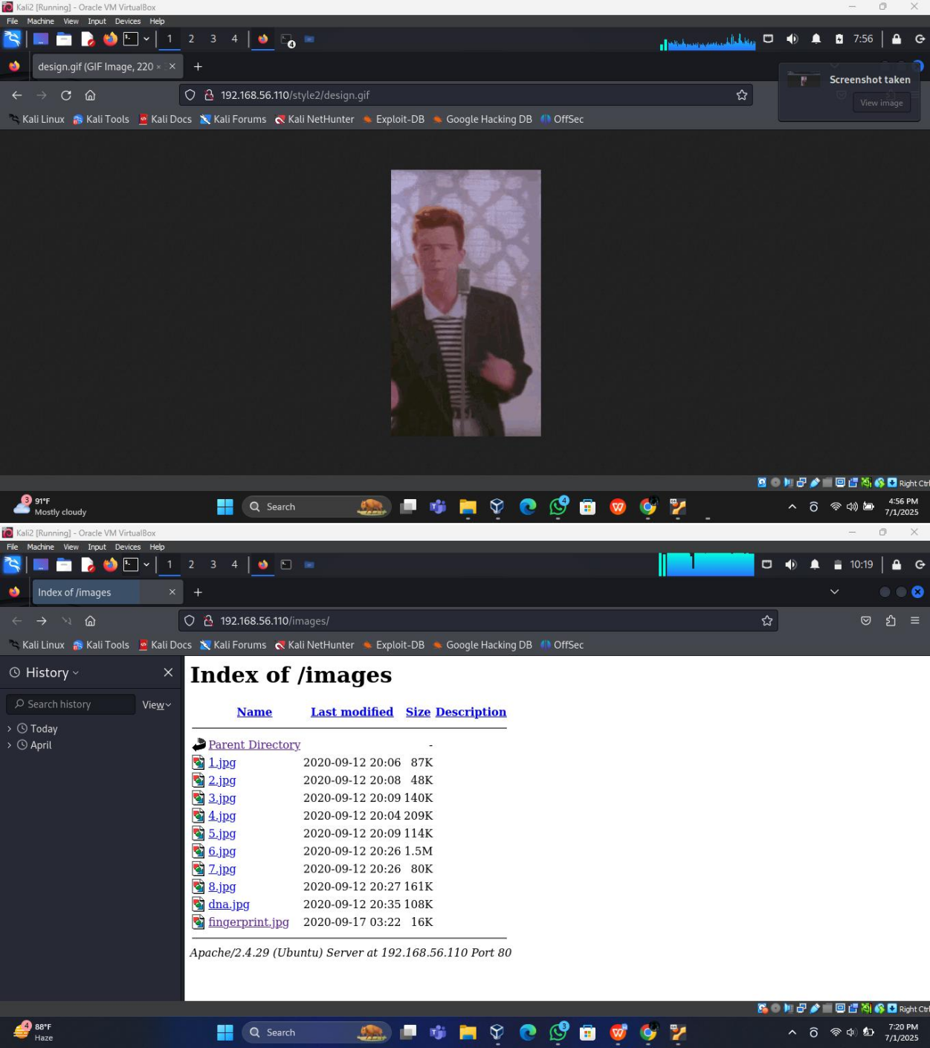

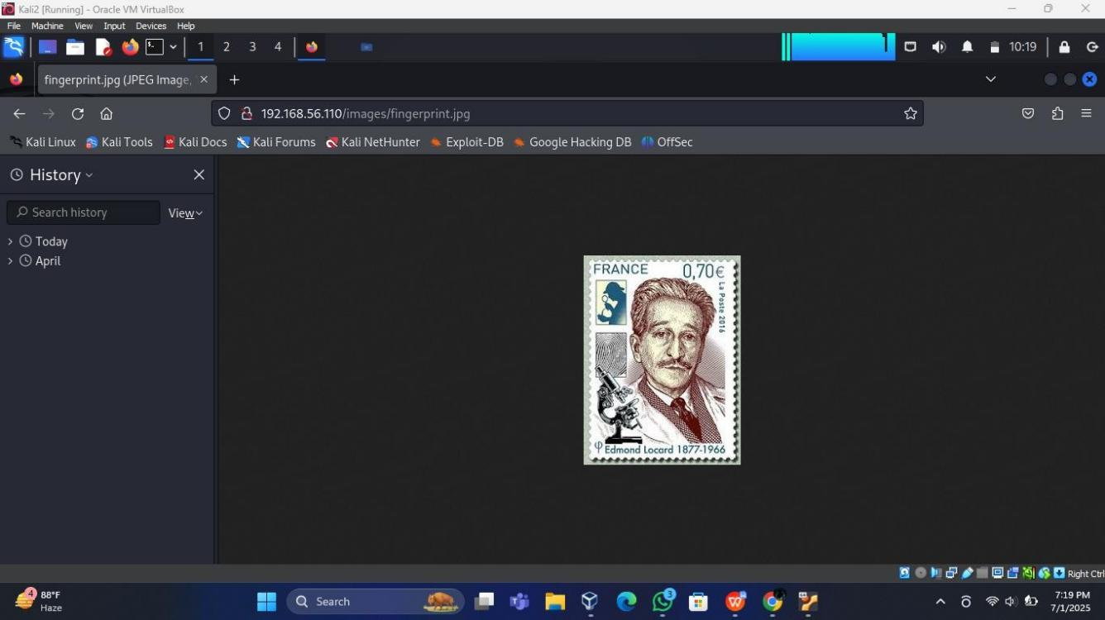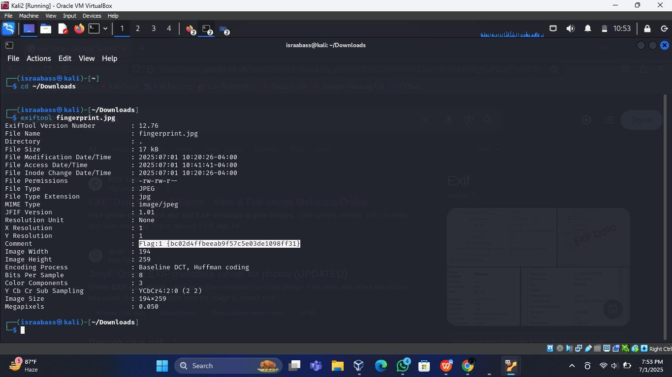

FLAG NO : 02

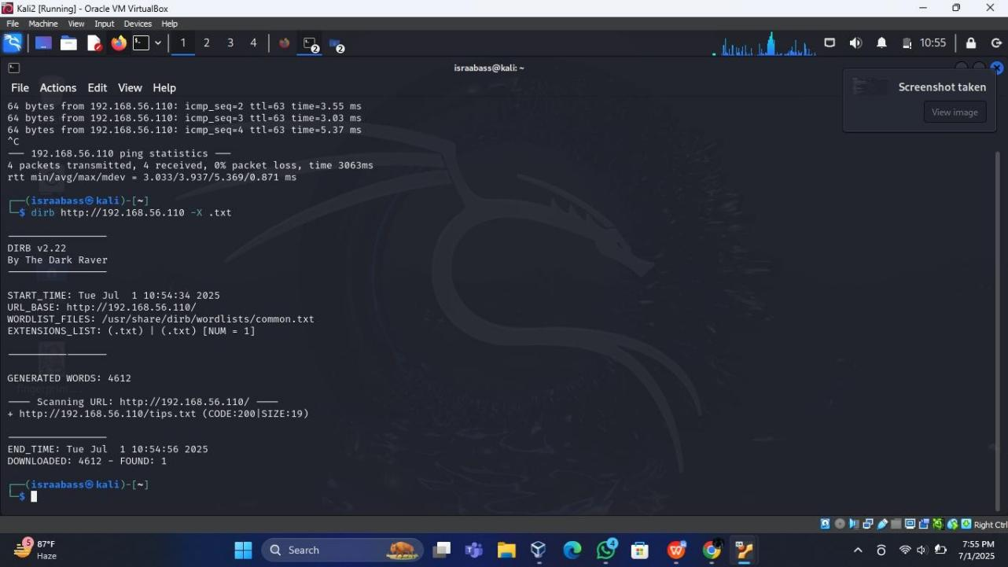

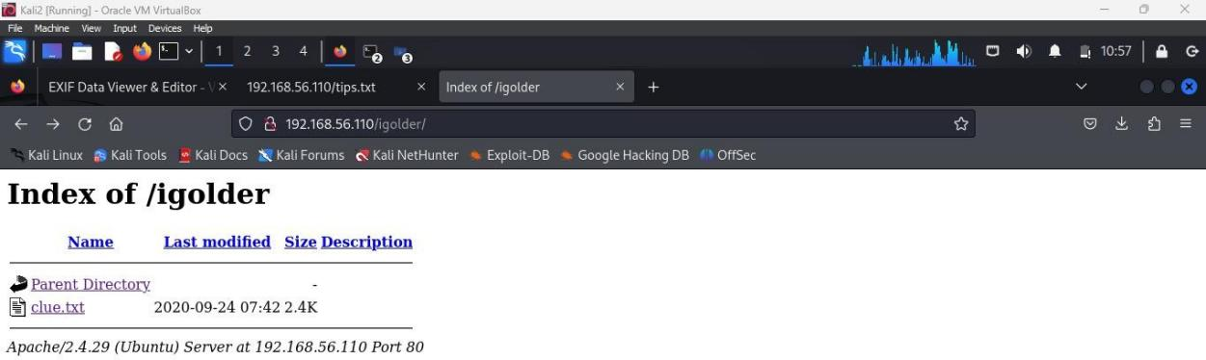

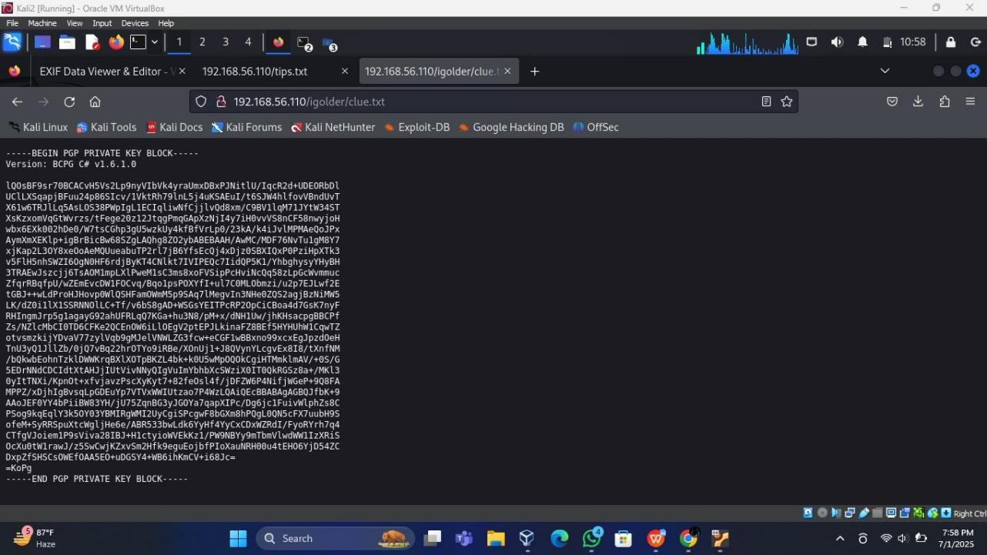

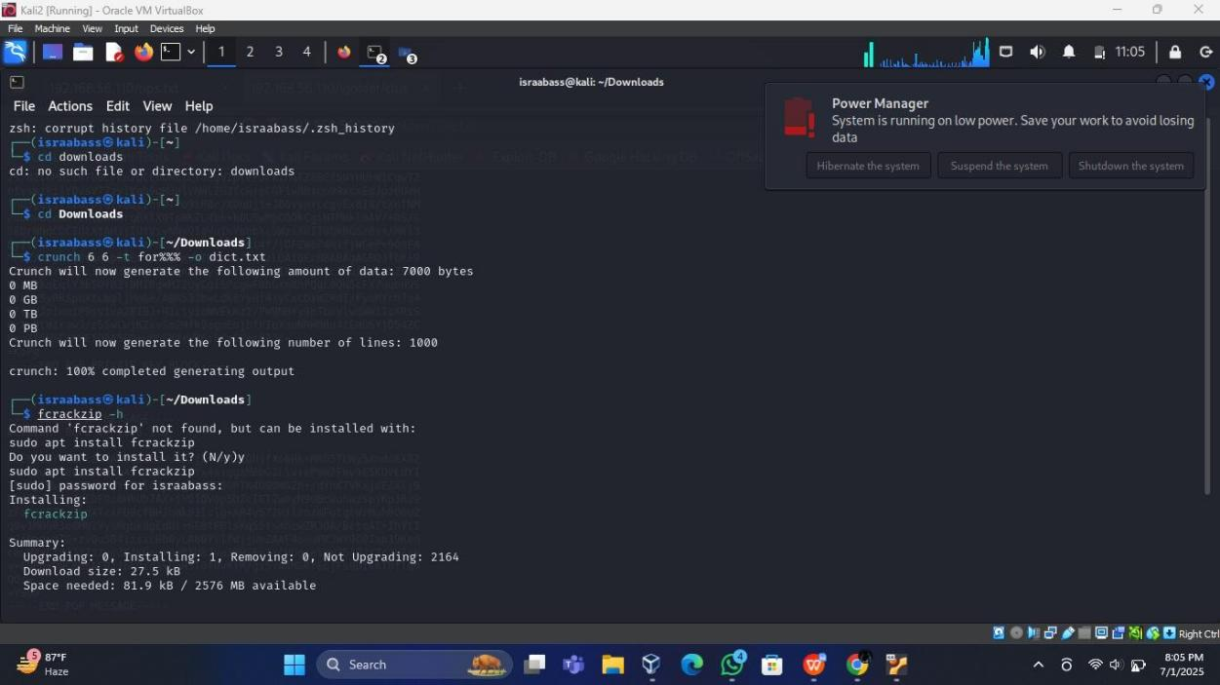

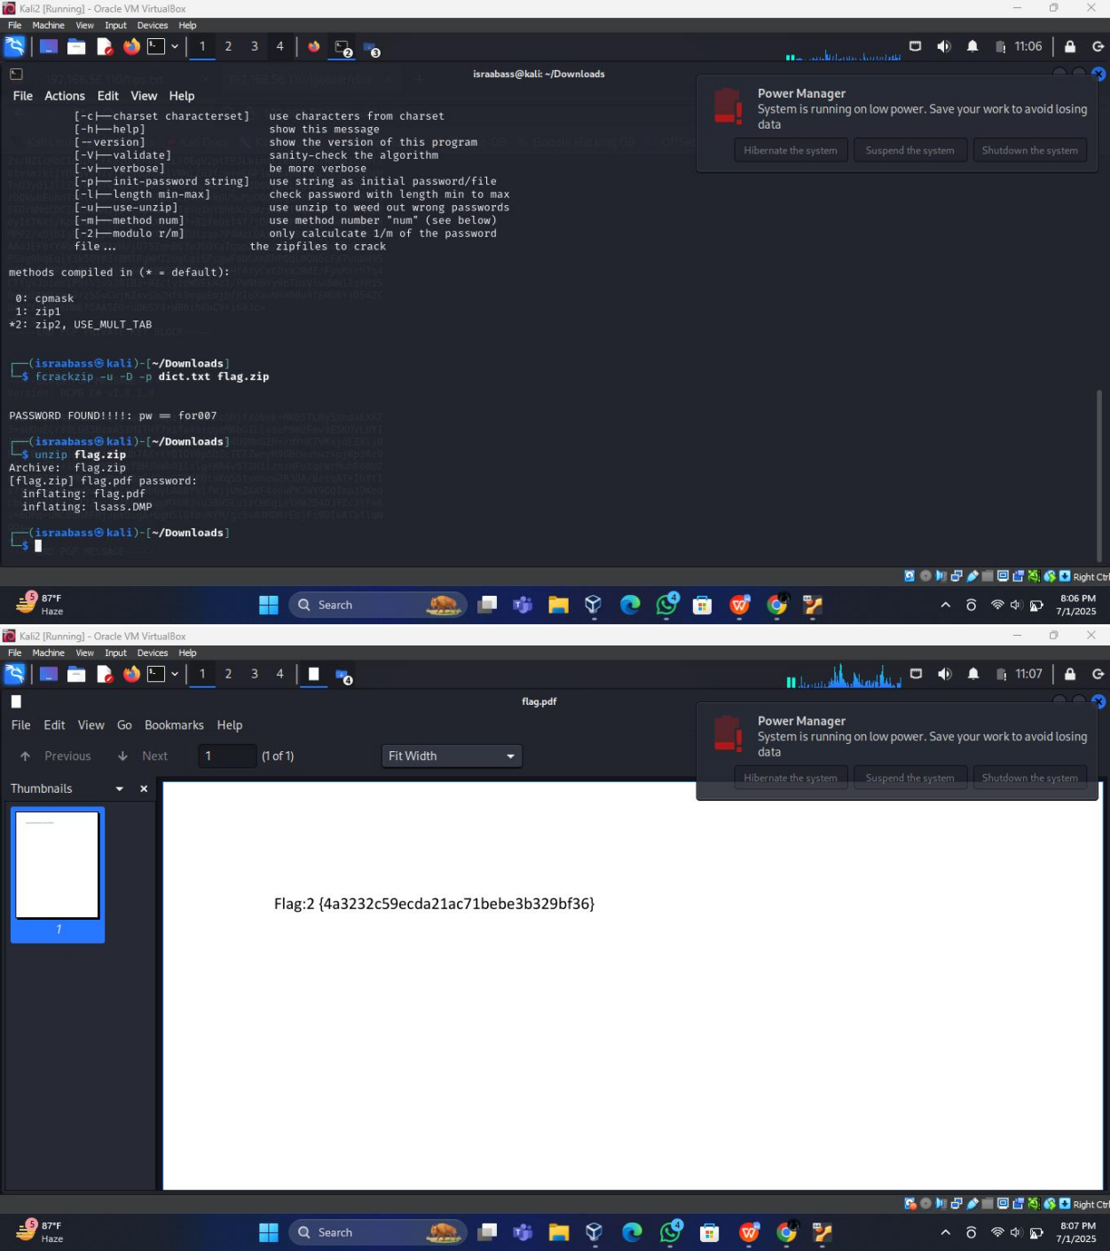

FLAG 04

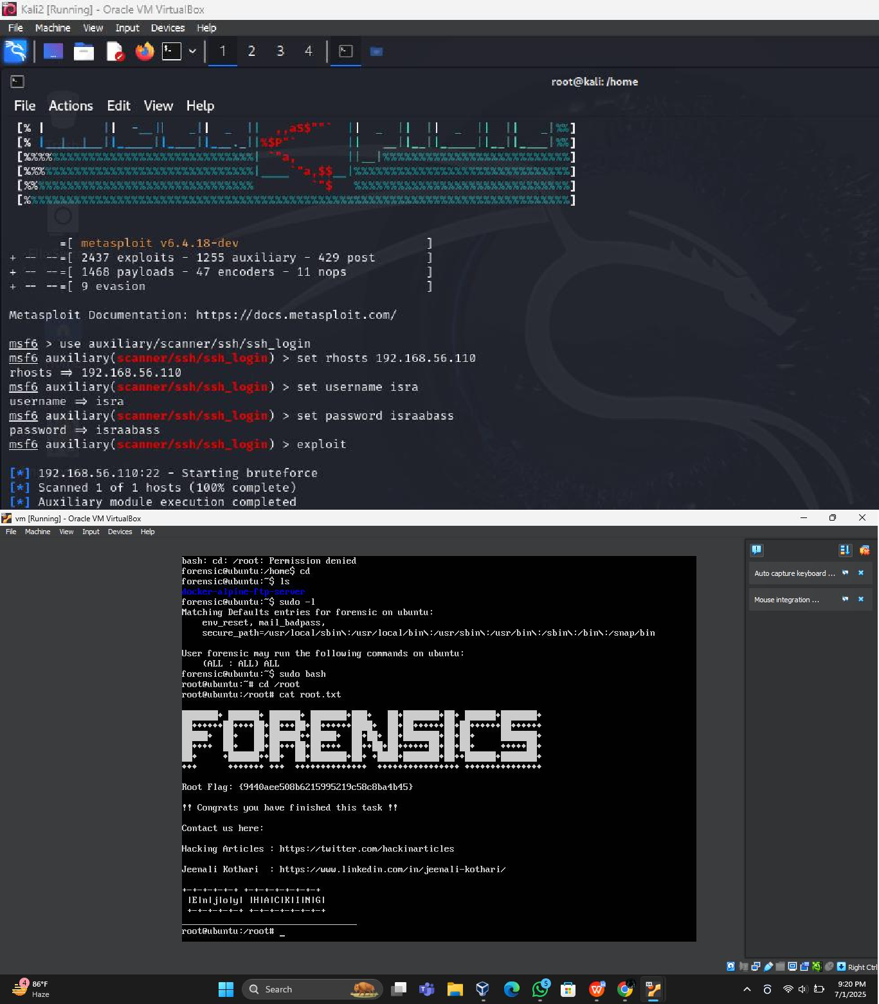

FLAG 3

